ISP Webinar Worksheet #6
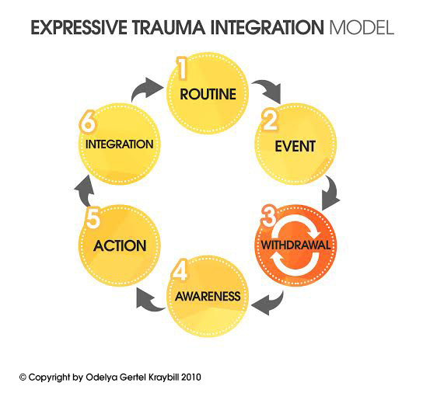
ETI Roadmap on Self - Small trauma
Choose a personal small trauma that took place over a year ago. Fill in the following stages with your story outline.

Routine ______________________________________________________________
Event ________________________________________________________________
_____________________________________________________________________
_____________________________________________________________________
Withdrawal ___________________________________________________________
_____________________________________________________________________
_____________________________________________________________________
Awareness ____________________________________________________________
_____________________________________________________________________
Action _______________________________________________________________
_____________________________________________________________________
_____________________________________________________________________
Integration ____________________________________________________________
_____________________________________________________________________
Routine ______________________________________________________________
_____________________________________________________________________

